Month = 4

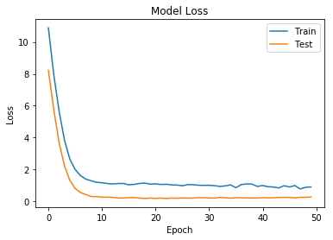

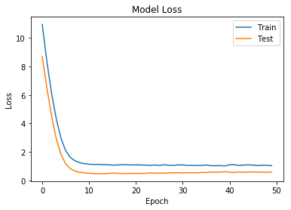

14/14 [==============================] - 0s 577us/step - loss: 1.3987 - mse: 1.2433

14/14 [==============================] - 0s 616us/step - loss: 1.0669 - mse: 0.9601

Final Train RMSE for Model One: 0.872

Final Train RMSE for Model Two: 0.966

Final Test RMSE for Model One: 1.182

Final Test RMSE for Model Two: 1.032

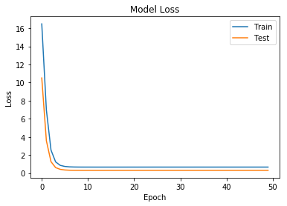

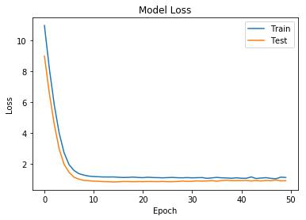

14/14 [==============================] - 0s 552us/step - loss: 1.2605 - mse: 1.2139

14/14 [==============================] - 0s 675us/step - loss: 0.7888 - mse: 0.6784

Final Train RMSE for Model One: 0.709

Final Train RMSE for Model Two: 1.011

Final Test RMSE for Model One: 1.122

Final Test RMSE for Model Two: 0.888

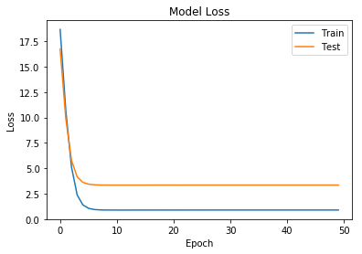

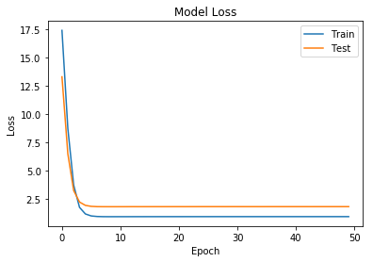

14/14 [==============================] - 0s 796us/step - loss: 0.7834 - mse: 0.4732

14/14 [==============================] - 0s 803us/step - loss: 1.1626 - mse: 1.0788

Final Train RMSE for Model One: 0.742

Final Train RMSE for Model Two: 0.942

Final Test RMSE for Model One: 0.885

Final Test RMSE for Model Two: 1.078

Month = 90

10/10 [==============================] - 0s 599us/step - loss: 0.4297 - mse: 0.3024

10/10 [==============================] - 0s 588us/step - loss: 1.1821 - mse: 1.0099

Final Train RMSE for Model One: 0.993

Final Train RMSE for Model Two: 0.830

Final Test RMSE for Model One: 0.655

Final Test RMSE for Model Two: 1.087

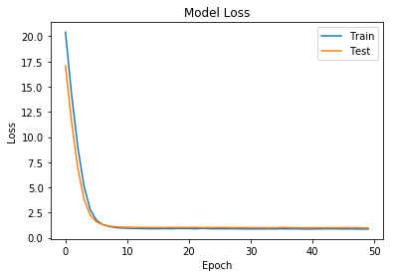

Month = 120

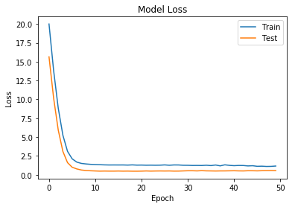

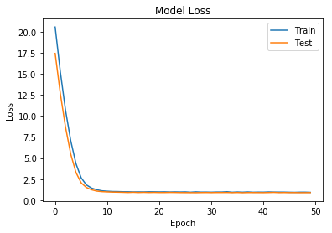

9/9 [==============================] - 0s 564us/step - loss: 0.5868 - mse: 0.3981

9/9 [==============================] - 0s 566us/step - loss: 0.9316 - mse: 0.7489

Final Train RMSE for Model One: 0.9821457522213365

Final Train RMSE for Model Two: 0.8680015386093145

Final Test RMSE, accuracy for Model One: [0.76605742 0.63093651]

Final Test RMSE, accuracy for Model Two: [0.96517837 0.86540227]

Month = 150

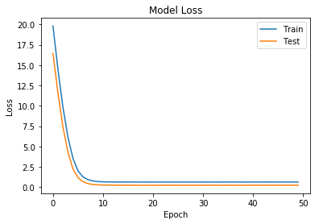

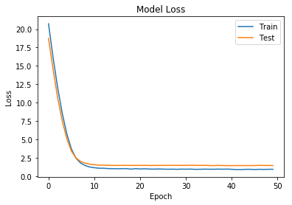

7/7 [==============================] - 0s 555us/step - loss: 2.7629 - mse: 2.7395

7/7 [==============================] - 0s 588us/step - loss: 0.9332 - mse: 0.7583

Final Train RMSE for Model One: 0.7779309532544074

Final Train RMSE for Model Two: 0.8619994576976867

Final Test RMSE, accuracy for Model One: [1.66219436 1.6551546 ]

Final Test RMSE, accuracy for Model Two: [0.96600251 0.8707928 ]

Month = 180

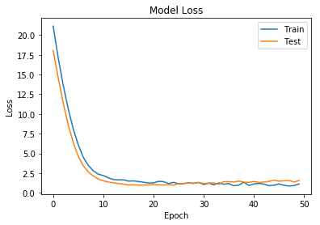

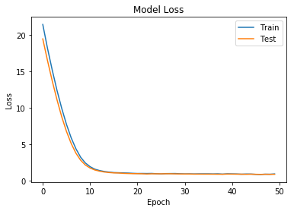

5/5 [==============================] - 0s 584us/step - loss: 0.8780 - mse: 0.4504

5/5 [==============================] - 0s 629us/step - loss: 1.2239 - mse: 1.0641

Final Train RMSE for Model One: 0.8379020779055917

Final Train RMSE for Model Two: 0.8799609150659831

Final Test RMSE, accuracy for Model One: [0.93699858 0.67114387]

Final Test RMSE, accuracy for Model Two: [1.10629926 1.03155172]

Month = 210

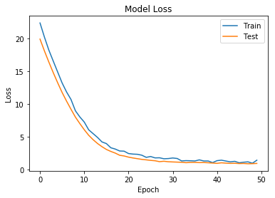

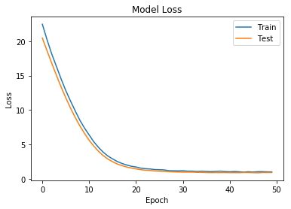

3/3 [==============================] - 0s 653us/step - loss: 1.9682 - mse: 1.2513

3/3 [==============================] - 0s 624us/step - loss: 1.0193 - mse: 0.7238

Final Train RMSE for Model One: 0.8544362077087269

Final Train RMSE for Model Two: 0.8528244746825778

Final Test RMSE, accuracy for Model One: [1.40292538 1.11863615]

Final Test RMSE, accuracy for Model Two: [1.00960021 0.85078321]

Month = 240

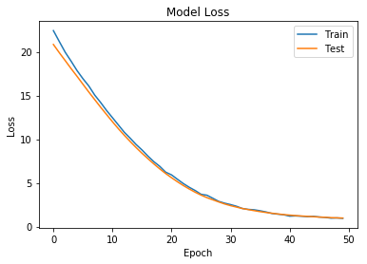

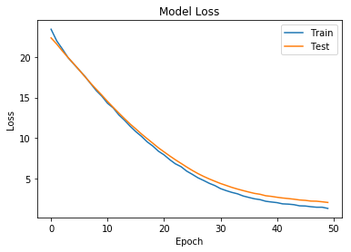

2/2 [==============================] - 0s 627us/step - loss: 2.0874 - mse: 1.4867

2/2 [==============================] - 0s 627us/step - loss: 1.5036 - mse: 0.5744

Final Train RMSE for Model One: 0.5658929537888395

Final Train RMSE for Model Two: 0.6251720668447962

Final Test RMSE, accuracy for Model One: [1.44476935 1.21930222]

Final Test RMSE, accuracy for Model Two: [1.22622511 0.75792446]